FCH7 -

Functionality
This function allows you to reprint a check. The check is reprinted and a new number is assigned for in the system, according the check lot.

Scenario
A check form was jammed in the printer and you need to reprint the check.

Requirements
A posted check.

Menu Path | Accounting → Financial Accounting → Accounts Payable → Environment → Check information → Change → FCH7 - Reprint check
Transaction Code | FCH7
1. Double click on FCH7 - Reprint check.

Reprint Check

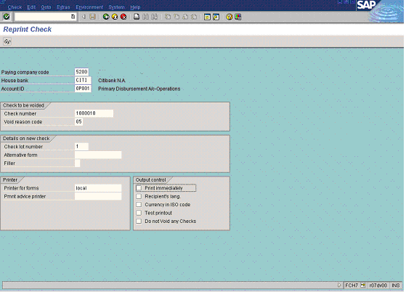

2. Update the following fields:

Field Name | Field Description | Values
Paying company code | In this field you find the company code that processes the payment transactions (possibly for other company codes too). | Example: 5200
House bank | Identification number for the house bank to which the transaction corresponds | Example: CITI
Account ID | Account defined for a house bank | Example: OP001
Check number | Number of the check you want to reprint | Example: 1000010
Check lot number | Description of the Check lot number. | Enter value in Check lot number.  Example: 1

3. Press [F4] or click the button in the Check Void Reason field

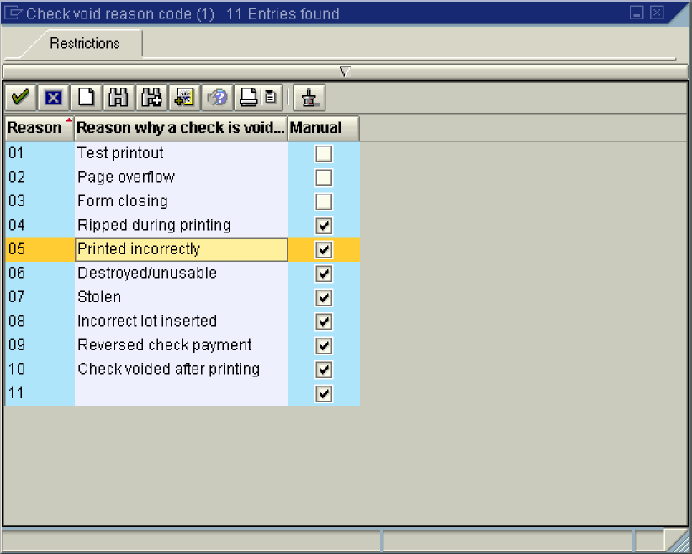

4. Select 05 - Printed incorrectly in list box.
5. Click Print immediately Button to send the printout directly to the printer:

6. Click Enter Button to confirm your entries.

7. To reprint the check, select Check -> Reprint from the menu path

8. The message bar displays “Check number 1000010 voided, check 1000011 reprinted”.

